|  |  |
| --- | --- |
| Q1 | What are the following are true about CSS? |
|  | a) Used to apply styles in html page b) Cannot be used in html page functionality  c) Can interact with database d) a&b |

|  |  |
| --- | --- |
| Q2 | What are the different ways to perform measurements in CSS |
|  | a) pixels & Inches b) centimeters & Points c) All of the above d) None of the above |

|  |  |
| --- | --- |
| Q3 | Following are properties used in CSS box model |
|  | a)Content b) Padding c) Border d) Margin e) All of the above |

|  |  |
| --- | --- |
| Q4 | How to import external css in to html page? |
|  | a) <script src="mystyles.css"> b) <link href="MyStyles.css" rel="stylesheet" />  c) Both of the above d) none of the above |

|  |  |
| --- | --- |
| Q5 | How to handle formatting of the browser window based on resizing? |
|  | a) Box Model b) Media Queries c) Web Workers c) None of the above |

|  |  |
| --- | --- |
| Q6 | Which of the following selector matches a element based on its class attribute? |
|  | a) Type Selector b) Universal Selector c) Descendant Selector d) Class Selector |

|  |  |
| --- | --- |
| Q7 | Following are supported selectors |
|  | a) Element Selector and ID selector b) class selector c) Groping selector d) All of the above |

|  |  |
| --- | --- |
| Q8 | Hexa Decimal format for RED Color |
|  | a) #FF0000 b) #00FF00 c)#0000FF d) #FFFFFF |

|  |  |
| --- | --- |
| Q9 | Which of the following selector selects all elements of E that have the attribute attr that end with the given value? |
|  | a) E[attr^=value] b) E[attr$=value] c) E[attr*=value] d) none of the mentioned |

|  |  |
| --- | --- |
| Q10 | Which of the following selector selects the elements that are checked? |
|  | a) E ~ F b) ::after c) :checked d) none of the mentioned |

|  |  |
| --- | --- |
| Q11 | Which section in HTML document is the correct place to refer to an external style sheet? |
|  | a) head section b)Top of the html script c) At <body> section d End of the HTML script code |

|  |  |
| --- | --- |
| Q12 | Which attribute in HTML tag is used to define an internal style sheet? |
|  | a) body b script c) style d) css |

|  |  |
| --- | --- |
| Q13 | CSS style to change the text color of an element? |
|  | a) text-color: b) text-color= c) color: d) fgcolor: |

|  |  |
| --- | --- |
| Q14 | Which property allows to specify distance between the list and the text relating to the list. |
|  | A) list-spacing B) marker-spacing C) marker-offset D) list-offset |

|  |  |
| --- | --- |
| Q15 | How do you change the font of an element? |
|  | a) font-family: b) c) f: d) font= |

|  |  |
| --- | --- |
| Q16 | How to change the left margin of an element |
|  | a) indent: b) margin-left: c) margin: d) text-indent: |

|  |  |
| --- | --- |
| Q17 | ___________ property allow to control the shape/style of bullet point in case of unordered lists, and style of numbering characters in <ol> |
|  | a) list-style-layout b)B) list-type-style c) list-type d) list-style-type |

|  |  |
| --- | --- |
| Q18 | ____________ property allow to specify how much space appear between the content of an element and the border. |
|  | a) Spacing b) Marking c) Padding d) Content-border |

|  |  |
| --- | --- |
| Q19 | State True or False for CSS outlines properties.  i) An outline does take up space  ii) Outline do not have to be rectangular.  iii) Outline is always the same on all sides. |
|  | a) i-True, ii-True, iii-False b) i-False, ii-False, iii-True  c) i-True, ii-False, iii-True d) i-False, ii-True, iii-True |

|  |  |
| --- | --- |
| Q20 | The following syntax to set margin around a paragraph will make- p{margin:10px 4%} |
|  | a) Top and bottom margin will be 10px and left and right margin will be 4% of total width.  b) Left and right margin will be 10px and top and bottom margin will be 4% of total height  c) Top margin will be 10px and other margins will be 4% of total width  d) Left margin will be 10px and other margins will be 4% oftotal width |

Task:

1) Apply CSS style to div for the following output

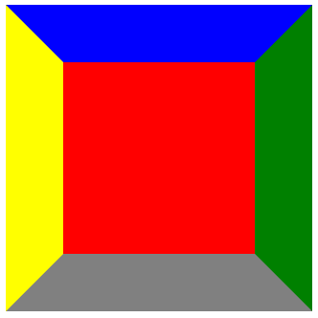 

2) Apply CSS style to list items for the following output

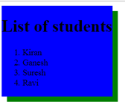

Reference links: https://www.w3schools.com/css/

|  |  |  |  |
| --- | --- | --- | --- |
| **Sl.No** | **Correct Option** | **Sl.No** | **Correct Option** |
| 1 | d | 11 | a |
| 2 | c | 12 | c |
| 3 | e | 13 | c |
| 4 | b | 14 | c |
| 5 | b | 15 | a |
| 6 | d | 16 | b |
| 7 | d | 17 | d |
| 8 | a | 18 | c |
| 9 | b | 19 | d |
| 10 | c | 20 | a |

**symantic tags:** Design the web page with the following css style

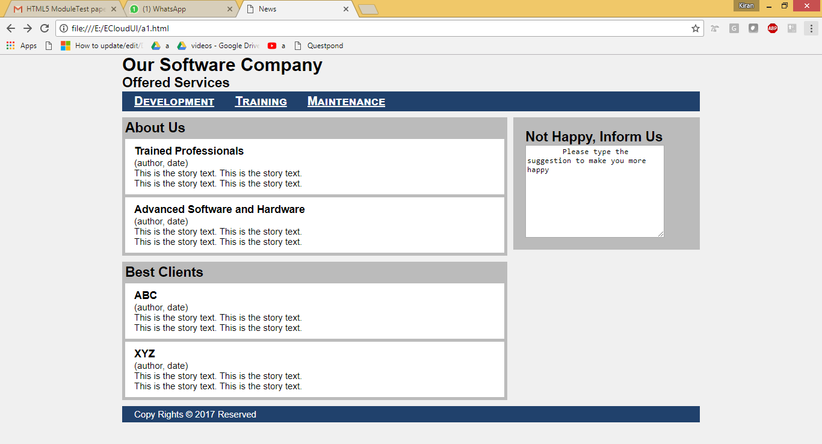

|  |  |
| --- | --- |
|  |  |
| A1.html | <style>@charset "UTF-8";    article, aside, footer, header, main, nav, section {  display: block;  }    html, body, h1, h2, h3, ul, li, a, p,  article, aside, footer, header, main, nav, section {  padding: 0;  margin: 0;  }    .banner {  background-color: #11233b;  color: white;  padding: 10px 20px;  }    body {  width: 960px;  margin-left: auto;  margin-right: auto;  background-color: #f0f0f0;  font-family: Helvetica, Arial, sans-serif;  font-size: 15px;  }    nav {  background-color: #20416c;  padding: 5px;  margin-top: 1px;  }    li a {  color: white;  }    li {  display: inline;  margin-left: 15px;  margin-right: 15px;  font-size: 20px;  font-variant: small-caps;  font-weight: bold;  }    section {  background-color: #bbbbbb;  margin-top: 10px;  padding: 5px;  }    article {  background-color: white;  margin-top: 5px;  padding: 10px 15px;  }    main {  width: 640px;  float: left;  margin-bottom: 10px;  }    aside {  background-color: #bbbbbb;  width: 270px;  float: right;  padding: 20px;  margin-top: 10px;  }    footer {  clear: both;  background-color: #20416c;  color: white;  padding: 5px 20px;  }  </style>  <!DOCTYPE html>  <html lang="en">  <head>  <meta charset="UTF-8">  <title>News</title>  </head>  <body>  <header>  <h1>Our Software Company</h1>  <h2>Offered Services </h2>  </header>  <nav>  <ul>  <li><a href="development.html">Development</a></li>  <li><a href="training.html">Training</a></li>  <li><a href="Maintenance.html">Maintenance</a></li>  </ul>  </nav>  <main>  <section>  <h2>About Us</h2>  <article>  <header>  <h3>Trained Professionals</h3>  <p>(author, date)</p>  </header>  <p>This is the story text. This is the story text.</p>  <p>This is the story text. This is the story text.</p>  </article>  <article>  <header>  <h3>Advanced Software and Hardware</h3>  <p>(author, date)</p>  </header>  <p>This is the story text. This is the story text.</p>  <p>This is the story text. This is the story text.</p>  </article>  </section>  <section>  <h2>Best Clients</h2>  <article>  <header>  <h3>ABC</h3>  <p>(author, date)</p>  </header>  <p>This is the story text. This is the story text.</p>  <p>This is the story text. This is the story text.</p>  </article>  <article>  <header>  <h3>XYZ</h3>  <p>(author, date)</p>  </header>  <p>This is the story text. This is the story text.</p>  <p>This is the story text. This is the story text.</p>  </article>  </section>  </main>  <aside>  <h2>Not Happy, Inform Us</h2>  <textarea name="" id="" cols="30" rows="10">  Please type the suggestion to make you more happy  </textarea>  </aside>  <footer>  <p>Copy Rights &copy; 2017 Reserved</p>  </footer>  </body>  </html> |